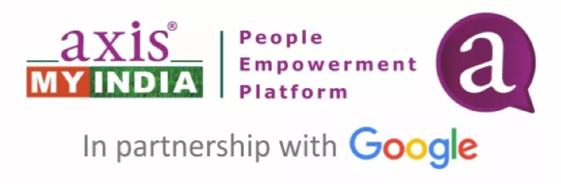SMART AMI HACKATHON 2025

# 1. Cover Page

Project Title:  
Team Name:  
Team Members:  
Contact Information:

# 2. Abstract

A concise summary of the problem, proposed solution, tech stack, and expected impact (150–200 words).

# 3. Problem Statement

Detailed explanation of the problem, existing solutions and limitations, and the uniqueness of your approach.

# 4. Objectives

Specific goals of the project and success criteria.

# 5. Proposed Solution

Solution overview, system architecture/workflow diagram, tools, frameworks, and APIs used.

# 6. Implementation

## 6.1 Frontend Module (e.g., React/HTML)

Description of the logic.

Code Snippet:

Example input/output if applicable.

## 6.2 Backend Module (e.g., Python/Node.js)

Description of the logic.

Code Snippet:

Example input/output if applicable.

## 6.3 ML/AI Model (if applicable)

Description of the logic.

Code Snippet:

Example input/output if applicable.

## 6.4 Database Schema / Queries

Description of the logic.

Code Snippet:

Example input/output if applicable.

# 7. Results & Output

Description of the working system, screenshots, sample run-through.

# 8. Evaluation

Performance metrics, user feedback, benchmarks or comparisons.

# 9. Challenges & Learnings

Technical difficulties, team collaboration insights, what you’d do differently.

# 10. Future Scope

Enhancements, scalability, deployment or open-source plans.

# 11. References

Libraries, papers, APIs, tutorials, and license attributions.

# 12. Appendix

GitHub Repository Link:  
README with setup instructions:  
Extra screenshots or logs:  
Full source code (as zip or included):